Welcome to Kenner Civil Service Jobs Online! The Kenner Civil Service vacancies are now posted online using NEOGOV software. This guide is provided to help you understand the online application requirements and thus help you prepare a complete and successful application. This document provides answers to questions that often arise for first-time users as well as helpful resources.
Getting Started
- Arrange access to a computer with a web browser program (such as Internet Explorer or Google Chrome). NEOGOV is a web based application system. The Kenner Civil Service Jobs Online Application system supports all web browsers used by majority of all applicants, but we find that Microsoft Internet Explorer 11, Microsoft Edge, version 20 and higher, and Google Chrome, version 72 and higher work the best. If you encounter difficulty in the application process, upgrading to one of these browsers may resolve your issues.
- Sign up for or use an email address that you will check regularly. A valid email address is needed to create an applicant account as well as receive notifications through the NEOGOV system. This way you will receive notifications faster than relying on paper notices.
- Check your spam blocker and enable pop-ups. Be sure to allow emails from Kenner Civil Service Jobs Online sent from governmentjobs.com. Enabling pop-up messages from governmentjobs.com will enable you to receive important system messages.
- Set up your User Account. This is required to apply for positions. Write down your User Name and Password and keep it in a safe place. Your User Name and Password are required each time you sign into the system to apply for jobs or check the status of your application.

You will need to enter your User Name and Password each time exactly as were entered when you set up your account; therefore, pay close attention to uppercase/lowercase letters, spaces and special characters.
The process consists of the following steps:

- Create An Account, or
- Login to an Existing Account
- Search Job Opportunities
- Apply for a Job
- Subscribe to Job Notifications
- Check Application Status

Follow these steps to sign in:

Step 1. Go to www.kenner.la.us Select “Civil Service Jobs” or Go directly to https://www.governmentjobs.com/careers/kennerla

Step 2. Create a New Account
Follow these steps to create a new account:

- Point your web browser to www. https://www.governmentjobs.com/careers/kennerla

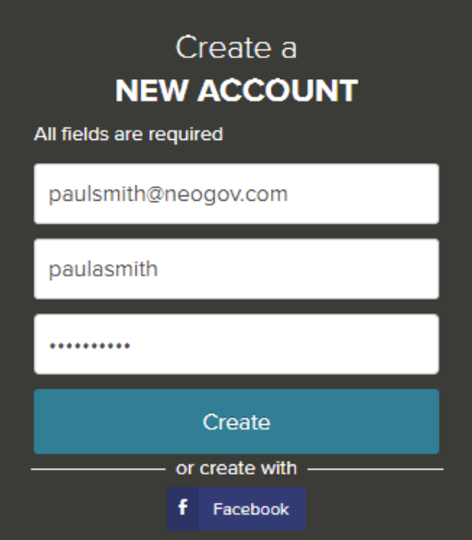

  - If you created an account before, you cannot use the same email address again to create a new account. The email value must be unique.
  - If you have a Linkedin or Facebook account those can be utilized to create your account as well.
  - If you created an account before and cannot remember you username, click on Forgot username. This sends you email with your username.
  - Your password must be at least six characters in length, and contain at least one number.
  - Answer the security question. In this example, type 14.
  - As you supply correct information for each field, a checkmark on the right indicates that the value is correct, for example:
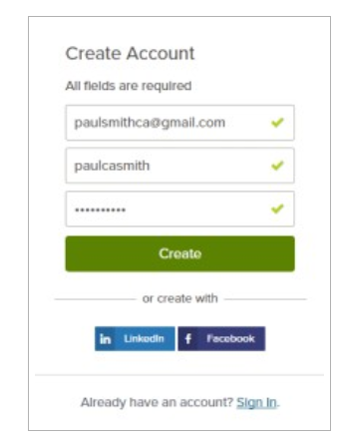

  - Click “Create”
When you are signed in, your username appears on the right in the top menu bar:
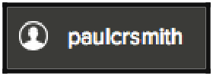
If you already created a user account, login using the previously created username and password. Otherwise, Click Create and create an account, and then enter your new account information.

  - If you are still unable to access your account or the system indicates that you already have an account, please contact NEOGOV Customer Support at 1-(855)-524-5627.

- Collect all the information you will need to complete your application. This includes your resume, work history, educational credentials (i.e., transcripts), licenses, DD214 (if applicable), Veterans Affairs disability letters, etc., and anything else that might be related to the positions for which you are applying.
    - You should be prepared to submit your transcript either electronically with the application or through other means (e.g., by mail, fax, email, etc.) when required to do so as stated in the particular posting.

    - Unofficial transcripts may be attached at the time of application; however, please keep in mind that official documents will be needed at the time of hire if you are offered a job.

    - Professional Licensure: Please provide your valid license number in the Certificates and Licensure section of the online application along with complete information such as issuing body, issue date, and expiration date. When applying to jobs in the future, be sure to update your profile to reflect the current expiration dates of licenses/certificates.

Step 3. Select the Job Opportunities link.

You can find jobs using the Search feature as follows.
- Type a job title in the search box. You can further limit the search by providing a state, city, or zip code. For example:

- Click Find Jobs. The jobs that match are shown, for example.
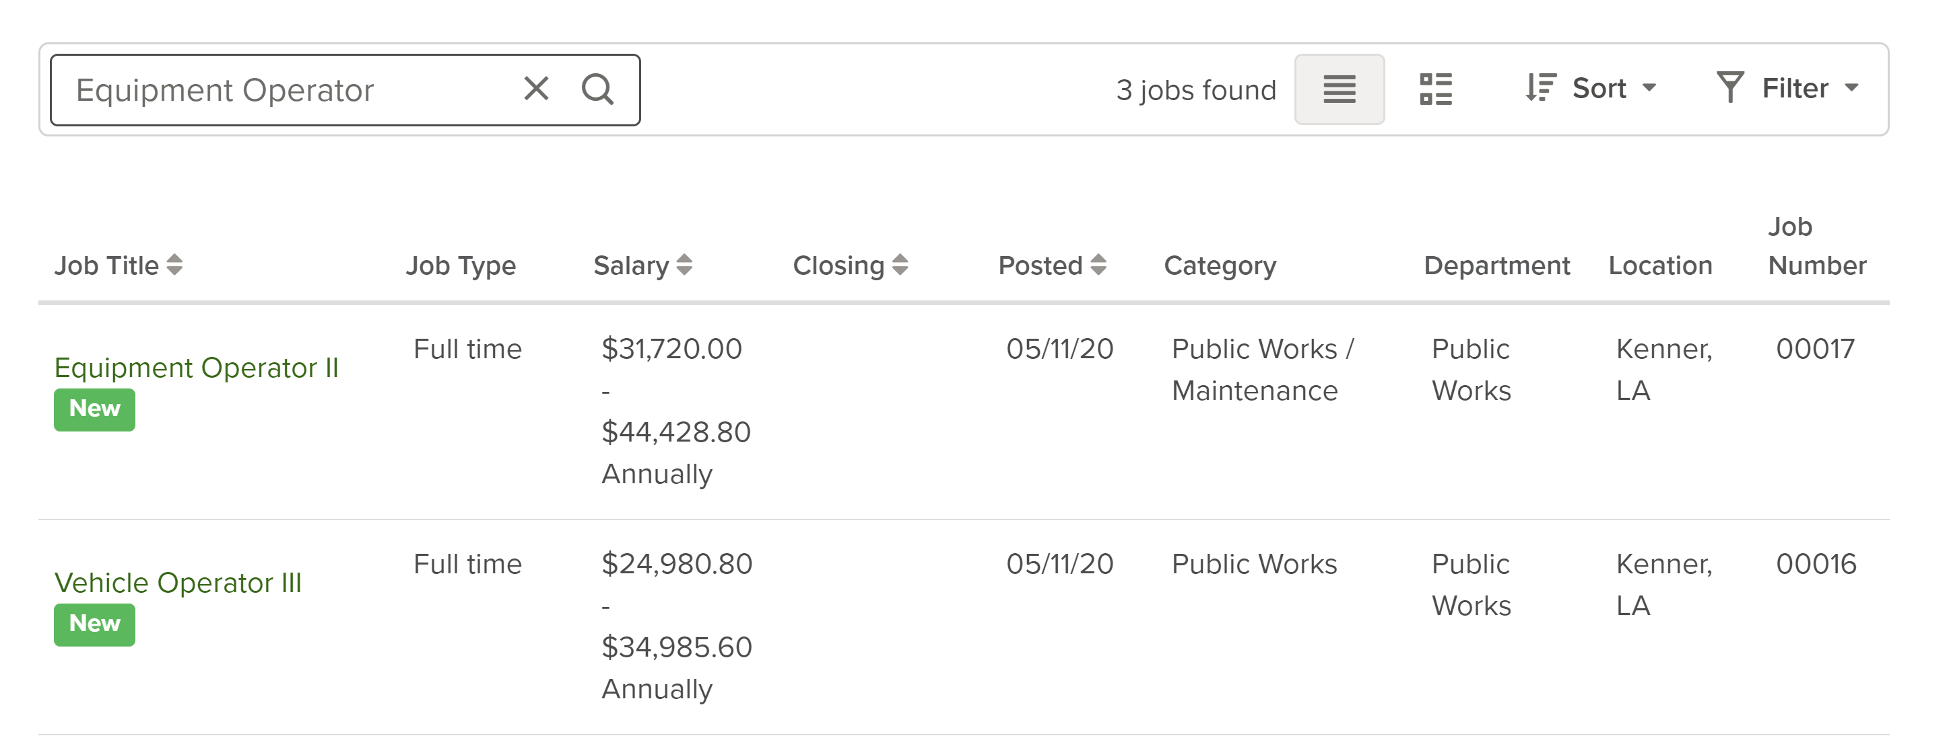
- Click on the title to open the job details.
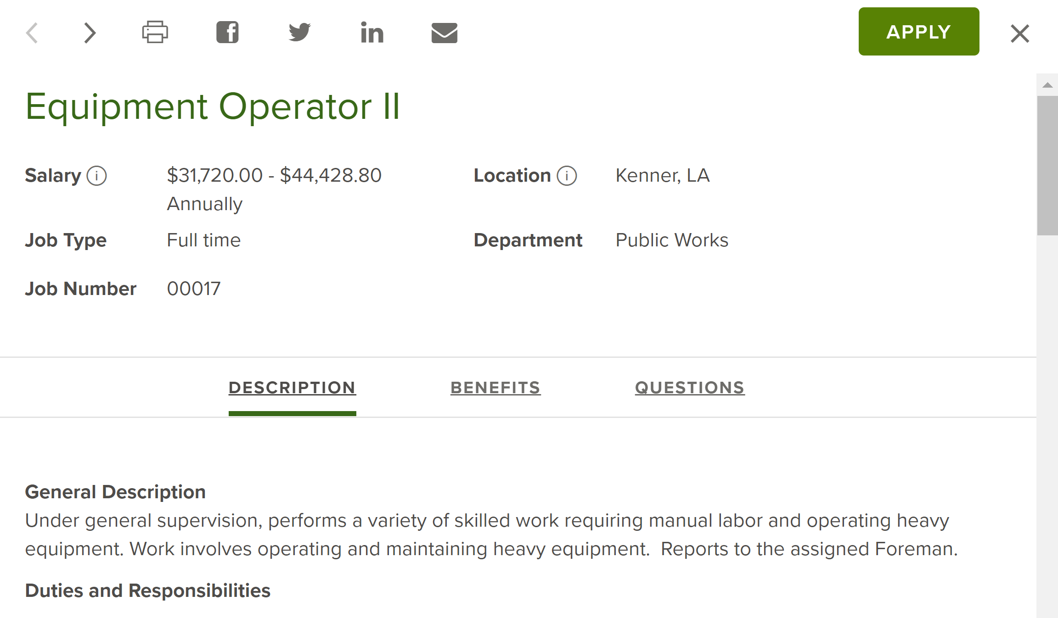

READ THE POSTINGS CAREFULLY. Review the job announcement carefully, noting the essential functions, minimum qualifications, and knowledge, skills & abilities. Your responses and associated documentation will determine your eligibility for the vacancy. Be sure to answer the agency-wide questions as well as any supplemental questions specific to each job.

- When it comes to questions about years of experience related to the position, be sure to count only your work experience that directly applies to the position. This means that you may answer questions differently for various positions for which you apply.

- Any experience claimed in the response to a supplemental question must be included in the experience portion of you online application and is subject to verification.

- It is a good practice to click on the Save button periodically as you complete your application. If you remain on a page for over 30 minutes without saving, you may lose the information you entered on the page. Typing does not extend the 30-minute session time-out. If you have enabled pop-ups, you will be asked if you would like to continue your session.
Step 4. Apply for a Job

To apply for a job click on the Apply button from job details:


Job Title: Custodian
Salary: $8.77 Hourly
Job Type: Part-time

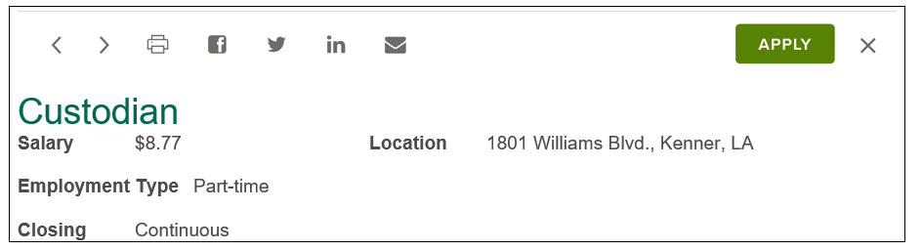

Step 5. Subscribe to Job Notifications (Job Interest Card) for Future Opportunities
To receive email notifications whenever a new job opportunity in a specific category becomes available, complete a Job Interest Card below.
Place a check in the box next to each job category for which you would like to receive email notifications, click the 'Subscribe' button, fill out the information, and then click the 'Submit' button.
For next 12 months after you subscribe, you will receive an email notification each time a position opens with City of Kenner whose category matches one of the categories you have chosen.
:

Step 6. Check Application Status
What happens after you apply?
    - Once you have submitted an application for a position with all required documents, your application is reviewed by a Civil Service staff member in relation to any required education and/or experience as stated in the minimum requirements on the posting.
    - If you meet the qualification any testing requirements, your name is placed on the eligible list.
    - Candidates are then referred to the hiring manager by the agency with the vacancy. All candidates on the eligible list are eligible to be referred.
    - The hiring manager then reviews the referral list and selects applicants for interview based upon test scores, qualifications, and suitability for the job. The hiring process will be specific to the position. Please keep in mind that it is up to the hiring manager to determine which referred candidates will be offered an interview.
    - You can check the status of your submitted applications at any time by logging into your account.
The chart below shows examples of the most common status messages and their meanings.

Application Status Message | What it Means
Application received | Your application has been submitted successfully.
Evaluating experience | Your application is under review by Civil Service to ensure you meet the minimum qualifications for the position.
Eligible for consideration | You are among a group of applicants who MAY be selected for the position.
Referred to hiring manager for review | Your application has been delivered to the hiring manager. You may or may not be called for an interview.
Position filled | Someone has been selected for the position.
Position cancelled | The agency has decided not to fill the position.

